Number Systems, Binary Operations
and Endianness

1. Introduction to Number Systems
A number system is a method of representing quantities using a defined set of symbols and a place-value rule. The most familiar system is decimal, which has ten symbols (0–9). Computers, however, work with electronic circuits that have two stable logical states, commonly represented as 0 and 1. This makes binary the natural language of digital systems.
Other number systems are mainly convenient ways for people to read and write binary values. Octal groups binary bits in sets of three, while hexadecimal groups them in sets of four. As a result, long binary strings can be represented much more compactly.
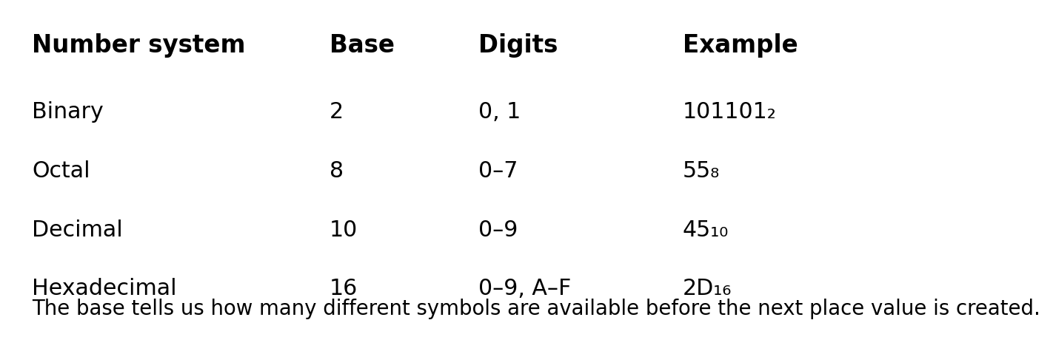

2. Binary Number System (Base 2)
Binary uses only two digits: 0 and 1. Each position represents a power of 2. Starting from the rightmost position, the place values are 2⁰, 2¹, 2², 2³, and so on.
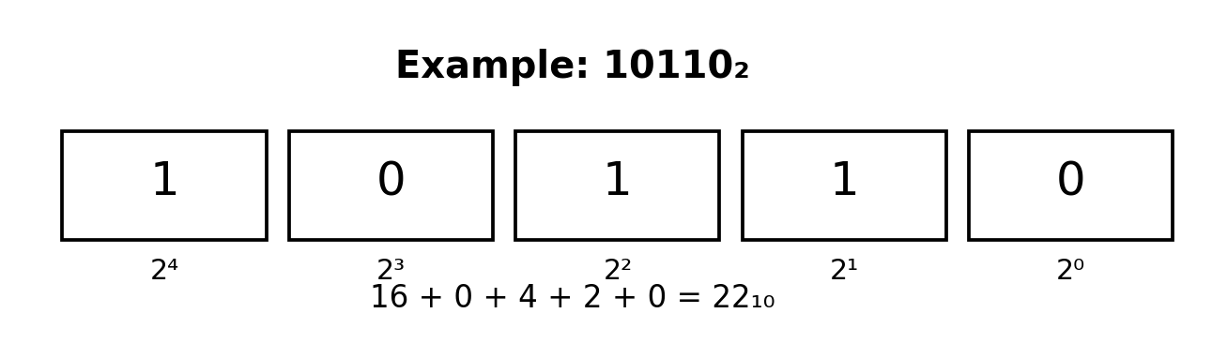
Example: Convert 10110₂ to decimal.
10110₂ = (1×2⁴) + (0×2³) + (1×2²) + (1×2¹) + (0×2⁰)
= 16 + 0 + 4 + 2 + 0 = 22₁₀
Therefore, 10110₂ = 22₁₀.

Why binary is used in computers
Digital circuits can reliably distinguish two electrical states, such as a low and high voltage. These states are interpreted as 0 and 1. A single binary digit is called a bit. Eight bits form one byte.
Example: 8-bit value 11001010₂ contains eight bits and can represent an unsigned decimal value from 0 to 255.

3. Octal Number System (Base 8)
Octal uses eight digits: 0 through 7. Each position represents a power of 8. Octal is useful because one octal digit maps exactly to three binary bits.
Example: Convert 157₈ to decimal.
157₈ = (1×8²) + (5×8¹) + (7×8⁰) = 64 + 40 + 7 = 111₁₀
Therefore, 157₈ = 111₁₀.
Example: Convert 1101011₂ to octal.
Group from the right in sets of three: 1 | 101 | 011
Pad the leftmost group if necessary: 001 | 101 | 011
001₂ = 1₈, 101₂ = 5₈, 011₂ = 3₈
Therefore, 1101011₂ = 153₈.

4. Decimal Number System (Base 10)
Decimal uses ten symbols: 0–9. It is the ordinary system used in everyday calculations. Each position is a power of 10.
Example: 583₁₀ = (5×10²) + (8×10¹) + (3×10⁰) = 500 + 80 + 3 = 583.
Although computers internally process binary data, decimal is often used in user interfaces, measurements, reports and instructions because it is familiar to people.

5. Hexadecimal Number System (Base 16)
Hexadecimal, or hex, uses sixteen symbols. The first ten are 0–9 and the remaining six are A–F. The letters represent decimal values 10–15.
Hex digit table:
Hex | 0 | 1 | 2 | 3 | 4 | 5 | 6
Decimal | 0 | 1 | 2 | 3 | 4 | 5 | 6
Hex | 7 | 8 | 9 | A | B | C | D
Decimal | 7 | 8 | 9 | 10 | 11 | 12 | 13
The remaining mapping is E = 14 and F = 15.
Example: Convert 2D₁₆ to decimal.
2D₁₆ = (2×16¹) + (13×16⁰) = 32 + 13 = 45₁₀
Therefore, 2D₁₆ = 45₁₀.
Example: Convert 101101₂ to hexadecimal.
Group four bits from the right: 0010 | 1101
0010₂ = 2₁₆ and 1101₂ = D₁₆, so 101101₂ = 2D₁₆.

6. Converting Between Number Systems
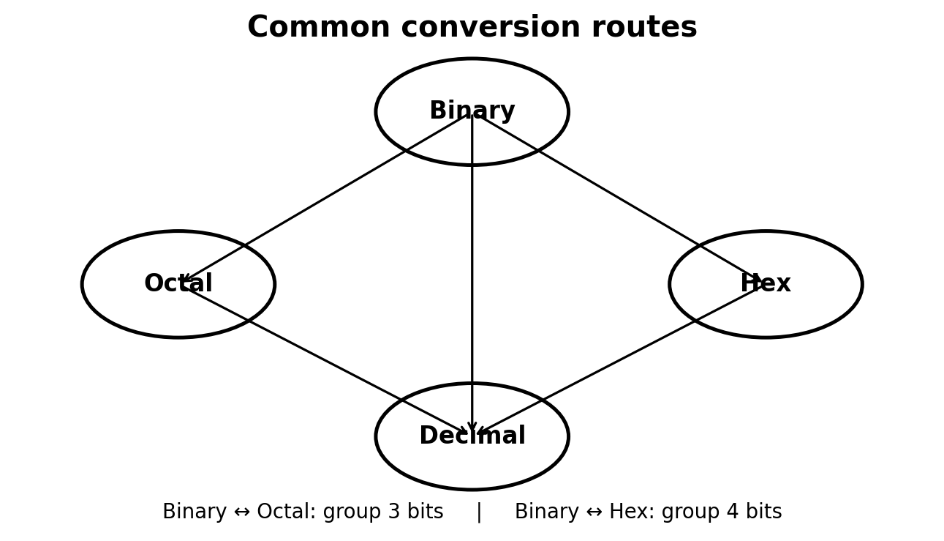

6.1 Binary to Decimal
Multiply each bit by its corresponding power of 2 and add the results.
Example: 110101₂
= (1×2⁵)+(1×2⁴)+(0×2³)+(1×2²)+(0×2¹)+(1×2⁰)
= 32+16+0+4+0+1 = 53₁₀

6.2 Decimal to Binary
Repeatedly divide the decimal number by 2. Record each remainder. The binary answer is obtained by reading the remainders from bottom to top.
Example: Convert 25₁₀ to binary.
25 ÷ 2 = 12 remainder 1
12 ÷ 2 = 6 remainder 0
6 ÷ 2 = 3 remainder 0
3 ÷ 2 = 1 remainder 1
1 ÷ 2 = 0 remainder 1
Read upward: 11001₂. Therefore, 25₁₀ = 11001₂.

6.3 Binary to Octal
Split the binary number into groups of three bits from the right.
Example: 10111001₂ → 010 | 111 | 001 → 2 | 7 | 1 → 271₈.

6.4 Octal to Binary
Replace every octal digit with its three-bit binary equivalent.
Example: 572₈ → 101 | 111 | 010 → 101111010₂.

6.5 Binary to Hexadecimal
Split the binary number into groups of four bits from the right.
Example: 11101101₂ → 1110 | 1101 → E | D → ED₁₆.

6.6 Hexadecimal to Binary
Replace each hexadecimal digit with its four-bit binary equivalent.
Example: 3A₁₆ → 0011 | 1010 → 00111010₂.

6.7 Decimal to Hexadecimal
Repeatedly divide the decimal value by 16 and record the remainders.
Example: Convert 254₁₀ to hexadecimal.
254 ÷ 16 = 15 remainder 14 → F, E
Therefore, 254₁₀ = FE₁₆.

7. Operations on Binary Number Systems
Binary arithmetic follows the same general ideas as decimal arithmetic, but only the digits 0 and 1 are available. The important difference is how carries and borrows are produced.

7.1 Binary Addition
Basic rules:
- 0 + 0 = 0
- 0 + 1 = 1
- 1 + 0 = 1
- 1 + 1 = 10₂ (write 0 and carry 1)
- 1 + 1 + 1 = 11₂ (write 1 and carry 1)
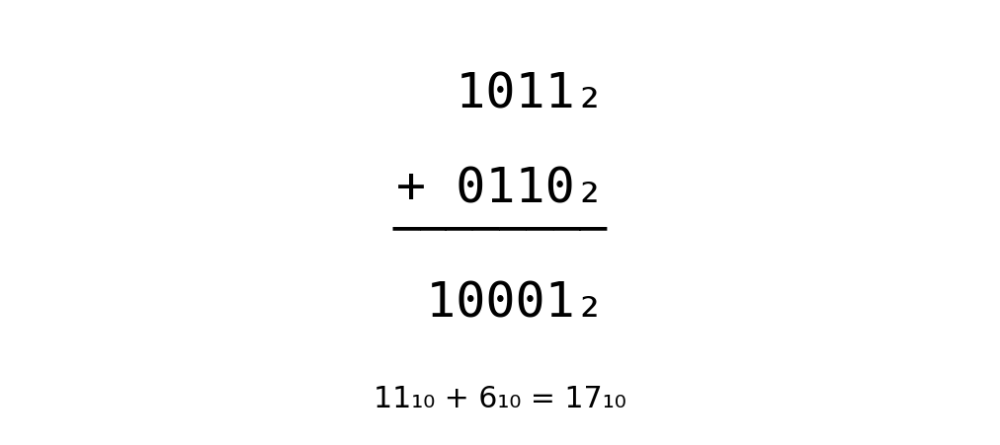
Example: 1011₂ + 0110₂ = 10001₂, which is 17₁₀.

7.2 Binary Subtraction
Basic rules:
- 0 − 0 = 0
- 1 − 0 = 1
- 1 − 1 = 0
- 0 − 1 requires a borrow. In binary, borrowing 1 from the next position gives 10₂ (two in decimal).
Example: 10110₂ − 00101₂ = 10001₂.
Check in decimal: 22 − 5 = 17, and 10001₂ = 17₁₀.

7.3 Binary Multiplication
Binary multiplication is simple because the multiplier contains only 0 and 1.
Rules: 0×0=0, 0×1=0, 1×0=0, 1×1=1.
Example: 101₂ × 11₂
101
× 11
─────
101
1010
─────
1111₂
Check: 5×3 = 15, and 1111₂ = 15₁₀.

7.4 Binary Division
Binary long division follows the same principle as decimal long division. At each step, determine whether the divisor fits into the current portion of the dividend, write 1 or 0 in the quotient, and continue.
Example: 1100₂ ÷ 10₂ = 110₂.
Check: 12 ÷ 2 = 6.

8. Bitwise Operations
Bitwise operations work directly on individual bits. They are widely used in programming, operating systems, networking, embedded systems and digital forensics.
Operation | Rule | Example | Result
AND | 1 only when both bits are 1 | 1010 AND 1100 | 1000
OR | 1 when either bit is 1 | 1010 OR 1100 | 1110
XOR | 1 when the bits are different | 1010 XOR 1100 | 0110
NOT | Inverts each bit | NOT 1010 | 0101 (4-bit example)
Example: 1010₂ AND 1100₂ = 1000₂. This operation can be used to test or clear selected bits using a mask.

9. Signed Binary Numbers and Two's Complement
Unsigned binary represents only non-negative values. Computers also need a way to represent negative integers. Two's complement is the most common representation for signed integers.
For an n-bit two's-complement number, the most significant bit acts as the sign bit: 0 indicates a non-negative value and 1 indicates a negative value.
Example: Represent −5 using 8 bits.
1. +5 = 00000101
2. Invert the bits = 11111010
3. Add 1 = 11111011
Therefore, −5 is represented as 11111011₂ in 8-bit two's complement.
Two's complement is important when interpreting binary data stored in memory, registers and executable files.

10. Bytes, Words and Memory Addresses
A byte contains 8 bits. Larger values are commonly grouped into words such as 16-bit, 32-bit and 64-bit quantities. When a value occupies more than one byte, the computer must decide the order in which those bytes are placed in memory. This is where endianness becomes important.
Example: The 32-bit hexadecimal value 0x12345678 consists of four bytes: 12, 34, 56 and 78.

11. Little-Endian and Big-Endian
Endianness describes the order in which the bytes of a multi-byte value are stored in memory. It does not change the numerical value itself; it changes the byte order used to represent that value in memory.
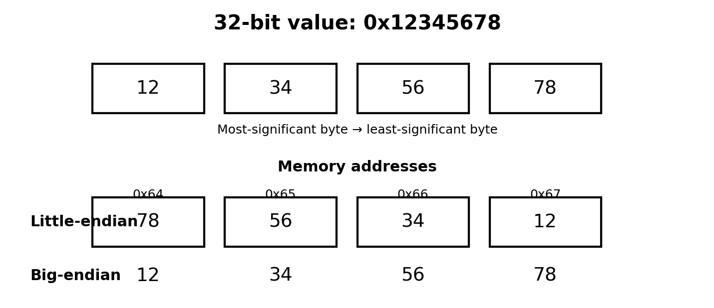

11.1 Little-Endian
In little-endian storage, the least significant byte (LSB) is stored at the lowest memory address. For 0x12345678, the byte sequence in increasing memory addresses is 78 56 34 12.
Example:
Address 0x100 → 78
Address 0x101 → 56
Address 0x102 → 34
Address 0x103 → 12
The important point is that the complete number is still 0x12345678. Only its byte arrangement in memory is reversed relative to the most-significant-byte-first representation.

11.2 Big-Endian
In big-endian storage, the most significant byte (MSB) is stored at the lowest memory address. For 0x12345678, the byte sequence in increasing memory addresses is 12 34 56 78.
Example:
Address 0x100 → 12
Address 0x101 → 34
Address 0x102 → 56
Address 0x103 → 78

11.3 Why Endianness Matters
- Interoperability: two systems must agree on byte order when exchanging multi-byte binary data.
- Network protocols: many Internet protocols use a standardized network byte order, commonly described as big-endian.
- Programming: a program reading raw memory must know how a multi-byte integer is laid out.
- Digital forensics: hexadecimal dumps and binary file structures may need to be interpreted according to the format's specified byte order.
- Reverse engineering: recognizing byte order helps an analyst correctly reconstruct integers, addresses and structure fields from raw bytes.

12. Worked Example: Reading Bytes from Memory
Suppose four consecutive memory locations contain the bytes shown below:
Address | 0x200 | 0x201 | 0x202 | 0x203
Byte | 78 | 56 | 34 | 12
If the system stores the value in little-endian format, these bytes represent 0x12345678. If the same four bytes were interpreted as big-endian, they would represent 0x78563412.
This is a useful reminder: the bytes themselves do not tell you the intended integer automatically. You also need the data format or architecture's byte-order convention.

13. Quick Reference Table
System | Base | Digits | Binary grouping | Typical use
Binary | 2 | 0–1 | — | Digital logic, machine data
Octal | 8 | 0–7 | 3 bits/digit | Compact binary notation; legacy systems
Decimal | 10 | 0–9 | — | Human-readable quantities
Hexadecimal | 16 | 0–9, A–F | 4 bits/digit | Memory addresses, machine code, file analysis

14. Practice Questions
1. Convert 101101₂ to decimal.
2. Convert 93₁₀ to binary.
3. Convert 11011101₂ to hexadecimal.
4. Convert 745₈ to binary.
5. Convert 3F₁₆ to decimal.
6. Perform 10101₂ + 11011₂.
7. Perform 11100₂ − 01011₂.
8. Perform 1011₂ × 101₂.
9. Calculate 1100₂ AND 1010₂, and 1100₂ XOR 1010₂.
10. The bytes 78 56 34 12 are stored at consecutive addresses. What 32-bit value do they represent under little-endian and big-endian interpretations?

